Gavriel Blau
DSC680 – Applied Data Science
Instructor: Amirfarrokh Iranitalab
Date: February 15, 2026
Automated Classification of Political Content on Twitter
Business Problem
Social media platforms generate vast volumes of user-generated content, much of which relates to political discourse. Researchers, policymakers, and analysts often need to identify political content to study public opinion, track trends, or conduct large-scale analyses. Manual classification of such content is time-consuming, inconsistent, and impractical at scale. Automated classification systems offer a potential solution but must address challenges such as informal language, ambiguity, and bias. This project examines whether supervised machine learning models can accurately classify Twitter posts as political or non-political using only textual features.
Background and History
Twitter has become a prominent platform for political communication, enabling rapid dissemination of opinions, news, and activism. The platform’s short-text format presents challenges for natural language processing, including limited context, slang, abbreviations, and rapidly evolving vocabulary. Early approaches to political content detection relied on keyword-based methods, which often failed to capture nuanced or indirect references. More recent research has demonstrated that statistical and machine learning approaches, particularly those using term frequency–based representations combined with linear classifiers, are effective for short-text classification tasks. This project builds on that work by applying supervised learning techniques to a real-world Twitter dataset.
Data Description
The dataset used in this project was obtained from Kaggle and consists of approximately 50,000 English-language tweets labeled as political or non-political. Each observation includes the raw tweet text and a binary label indicating whether the tweet contains political content. The distribution of labels shows that both classes are well represented, with a slight imbalance between political and non-political tweets, reflecting realistic social media usage patterns.
The tweets exhibit characteristics typical of social media data, including informal language, hashtags, user mentions, and short text length. Figure 1 illustrates the overall distribution of tweet lengths in the dataset, showing that most tweets contain relatively few words. This short-text structure limits contextual information and increases ambiguity, making political content classification a non-trivial task. Text preprocessing involved removing URLs and user mentions, converting all text to lowercase, and normalizing whitespace. Hashtags were retained as textual tokens, as they often contain informative cues related to political discourse.

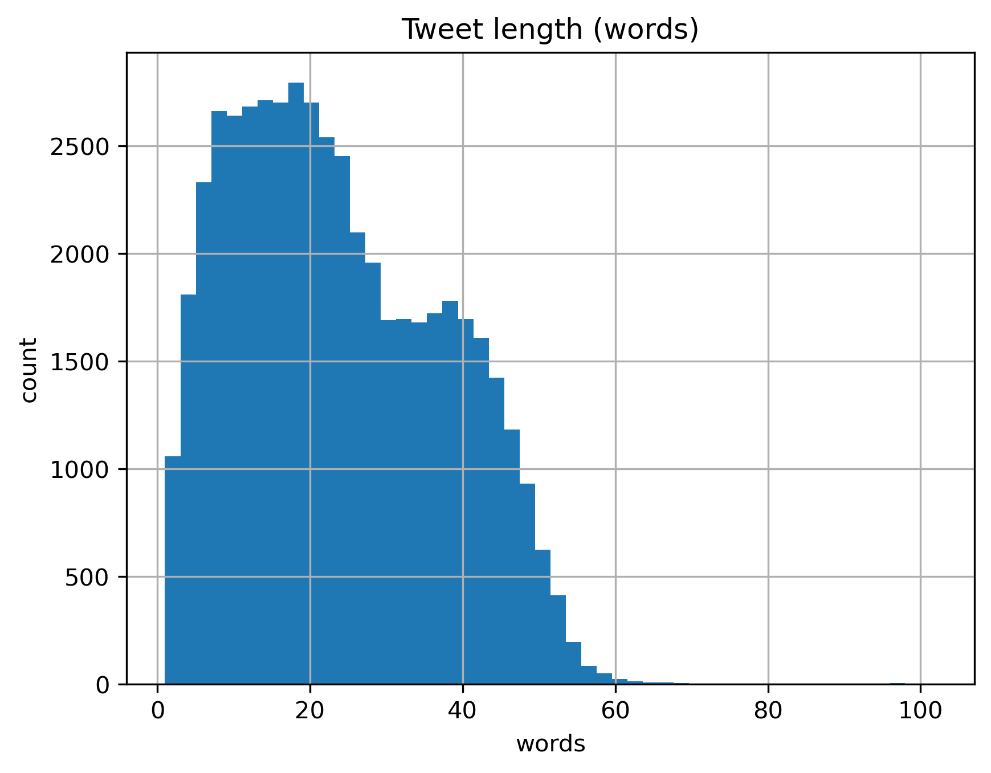
Figure 1. Distribution of tweet lengths in the dataset.
Methods
The analysis began with exploratory data analysis to assess class balance and tweet length distribution. Textual features were extracted using Term Frequency–Inverse Document Frequency (TF-IDF), incorporating both unigrams and bigrams in order to capture individual terms as well as short phrases common in political discourse.
Four models were trained and evaluated. A baseline Dummy classifier was used to establish a performance reference point. Three supervised learning models were then implemented: Multinomial Naive Bayes, Logistic Regression with class balancing enabled, and a Linear Support Vector Classifier (LinearSVC). Performance was evaluated using accuracy, precision, recall, F1-score, ROC-AUC, and precision–recall AUC to provide a comprehensive assessment under mild class imbalance.
Because Logistic Regression produces probabilistic outputs, additional evaluation was conducted through threshold tuning to identify a decision boundary that maximized the F1-score rather than relying on the default 0.5 cutoff. Calibration analysis was also performed to assess how well predicted probabilities aligned with observed outcomes. Finally, chi-square statistics were used to evaluate feature importance and identify terms most strongly associated with political classification.

Analysis
The baseline model confirmed that the classification task is non-trivial, as predicting only the majority class resulted in limited discriminatory performance. All supervised models substantially outperformed the baseline. Logistic Regression demonstrated strong balance between precision and recall, while LinearSVC achieved the highest overall accuracy on the test set.
The confusion matrix shown in Figure 2 indicates that the majority of tweets were correctly classified, with relatively few false positives and false negatives. However, misclassifications were more likely to occur when political tweets were predicted as non-political. This pattern suggests that implicit or context-dependent political references present a greater challenge than overt political language. The structure of these errors reinforces the importance of examining metrics beyond overall accuracy.

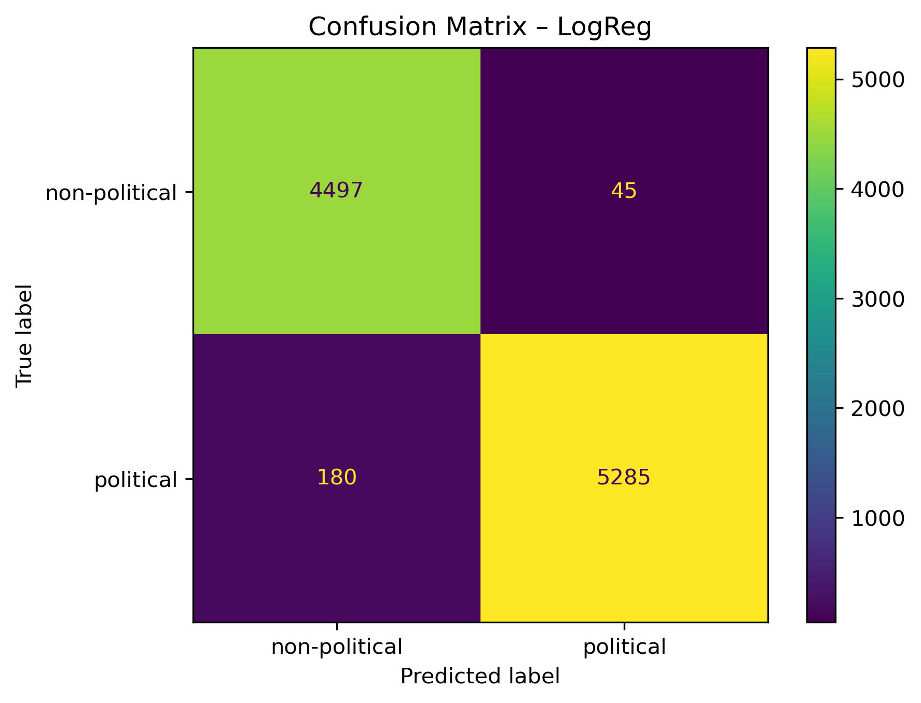
Figure 2. Confusion matrix for the Logistic Regression model.
The precision–recall curve in Figure 3 demonstrates that the model maintains high precision across most recall levels, with an average precision score of approximately 0.997. The ROC-AUC score of approximately 0.996 further confirms strong separability between classes. Threshold tuning improved the F1-score by selecting an optimal decision boundary that better balanced precision and recall, illustrating how model performance can be aligned with practical decision-making objectives rather than default settings.
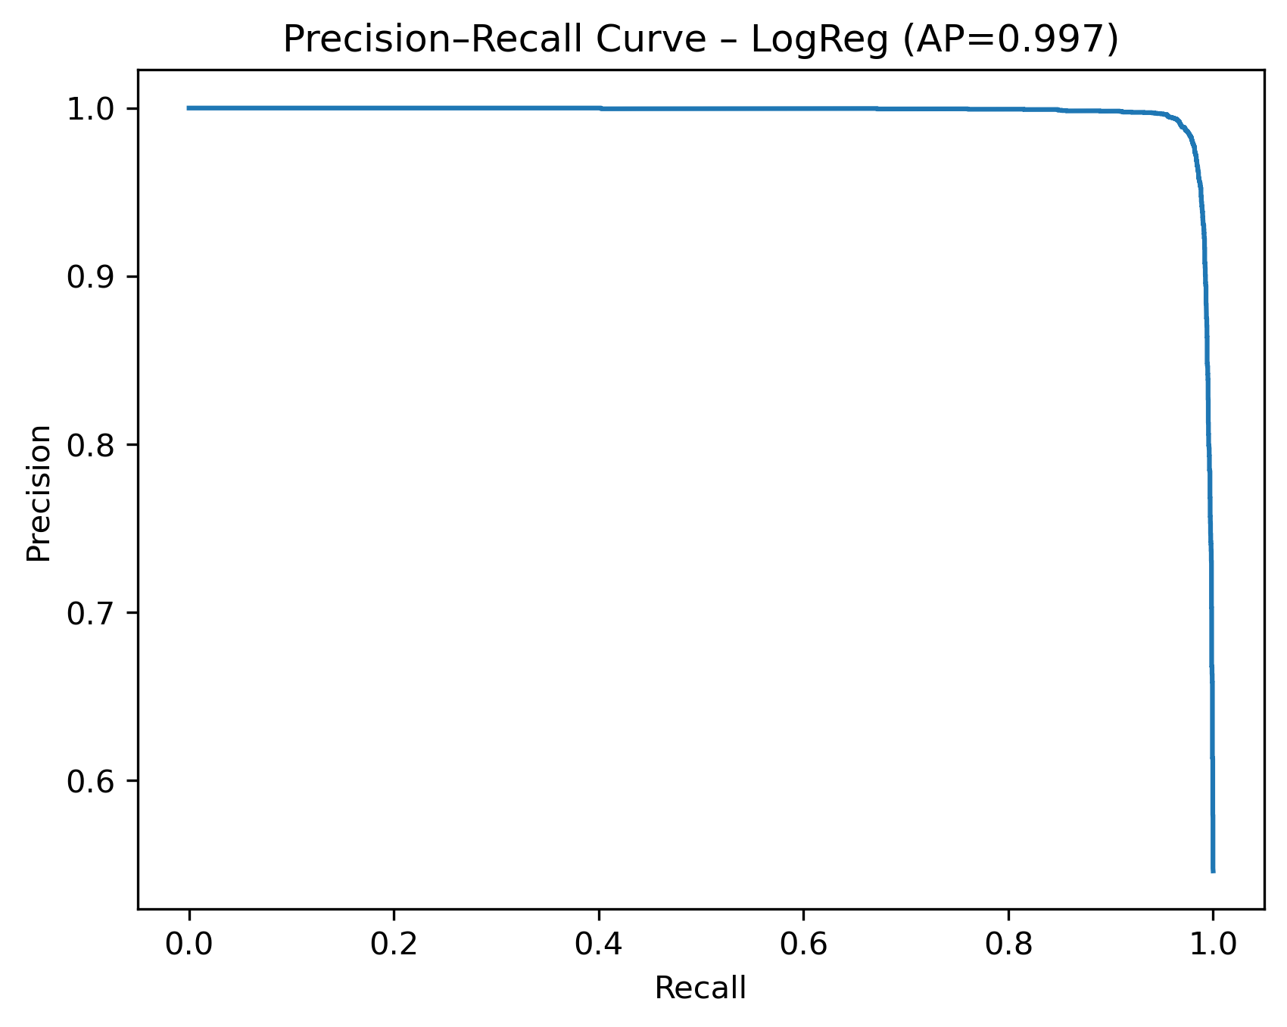
Figure 3. Precision–recall curve for the Logistic Regression model.
The steep initial rise in the precision–recall curve indicates that the model maintains high precision even as recall increases, demonstrating strong discriminative capacity.
Inspection of misclassified tweets revealed that false negatives often involved trending hashtags, indirect political references, or economically themed content without explicit political terminology. False positives occasionally included emotionally charged or nationally themed language that resembled political discourse without directly addressing political topics.
Feature analysis using chi-square statistics, illustrated in Figure 4, identified domain-specific vocabulary as highly informative for classification. Terms such as “politics,” “loksabhaelections2019,” “bjp,” “rahulgandhi,” and “modi” were among the strongest predictors. This confirms that politically salient terminology plays a central role in distinguishing political from non-political tweets.
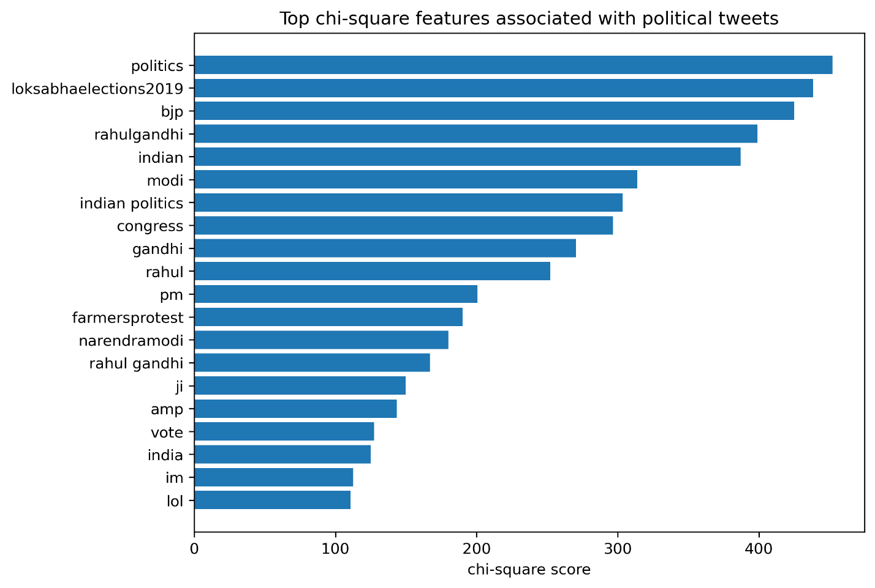
Figure 4. Top chi-square features associated with political tweets.

Conclusion
This study demonstrates that supervised machine learning models using TF-IDF features can effectively distinguish political from non-political tweets. Logistic Regression and LinearSVC achieved strong classification performance while remaining computationally efficient and interpretable. The inclusion of threshold tuning, calibration analysis, and structured error inspection strengthens the reliability of the findings and improves alignment with practical deployment considerations.
The results indicate that relatively straightforward linear models, when carefully validated and tuned, can provide robust performance on short-text classification tasks. However, ambiguity in language, indirect political references, and evolving discourse remain important limitations. Continued monitoring and periodic retraining would be necessary to maintain model reliability over time.

Assumptions
The analysis assumes that the dataset labels accurately represent political content and that English-language tweets are sufficient for identifying political discourse patterns. It also assumes that textual content alone provides enough information for classification.
Limitations
Tweets are often ambiguous, sarcastic, or lack sufficient context, which can lead to misclassification. The dataset reflects a specific regional and cultural context, limiting generalizability. Additionally, binary classification oversimplifies the complexity of political discourse.
Challenges
Key challenges included handling short text length, informal language, and class imbalance. Defining political content is inherently subjective, and this subjectivity may be reflected in labeling inconsistencies.
Future Uses and Additional Applications
Future work could extend this approach to multi-class political topic classification or incorporate metadata such as timestamps or user information. The model could also be used as a preprocessing step for downstream analyses such as sentiment analysis or topic modeling.
Recommendations
Accuracy alone should not be used to evaluate performance in this context. Precision–recall tradeoffs and decision threshold selection should guide deployment decisions, particularly when the relative cost of false negatives differs from false positives. Automated classification systems should supplement, rather than replace, human judgment in political analysis.
Implementation Plan
An operational pipeline would involve preprocessing incoming tweets, applying the trained model, and periodically retraining the model to account for linguistic drift. Performance monitoring would be required to ensure ongoing reliability.
Ethical Assessment
Automated classification of political content carries risks of bias, misclassification, and misuse. This project avoids ideological inference and is intended for analytical purposes only. Transparency regarding limitations and appropriate use is essential to prevent overreliance on automated systems.

Anticipated Audience Questions
- How reliable are the labels in the dataset, and who determined whether a tweet is political?
- Why was Logistic Regression chosen instead of more complex models such as neural networks or transformers?
- How does class imbalance affect model performance and interpretation of results?
- Can this model be used for content moderation or enforcement purposes?
- How well does the model handle sarcasm or indirect political references?
- Would incorporating additional data, such as user metadata or timestamps, improve classification accuracy?
- How generalizable are the results beyond this specific dataset and regional context?
- Why was TF-IDF used instead of word embeddings or deep learning–based representations?
- How often would the model need to be retrained to remain effective as language evolves?
- What ethical risks are associated with automated classification of political content?

References
Jurafsky, D., & Martin, J. H. (2023). Speech and language processing (3rd ed.). Draft manuscript. https://web.stanford.edu/~jurafsky/slp3/
Kaggle. (n.d.). Indian Twitter political classification dataset. https://www.kaggle.com/
OpenAI. (2024). ChatGPT (GPT-4-based large language model) [Large language model]. https://chat.openai.com/
Pedregosa, F., Varoquaux, G., Gramfort, A., Michel, V., Thirion, B., Grisel, O., … Duchesnay, É. (2011). Scikit-learn: Machine learning in Python. Journal of Machine Learning Research, 12, 2825–2830.
Twitter Developer Platform. (n.d.). https://developer.twitter.com

Appendix:
Text preprocessing was performed using standard natural language processing techniques. Tweet text was converted to lowercase, URLs and user mentions were removed, and excess whitespace was normalized. Hashtags were retained as part of the text, as they often contain meaningful contextual information related to political discourse.
Feature extraction was carried out using Term Frequency–Inverse Document Frequency (TF-IDF). Both unigrams and bigrams were included to capture individual terms as well as short phrases. Default scikit-learn parameters were used, with adjustments made to minimum document frequency to reduce noise from extremely rare terms.
The dataset was divided into training and testing subsets using an 80/20 split. A baseline dummy classifier was trained to establish a reference level of performance. Two supervised learning models were then trained: a Multinomial Naive Bayes classifier and a Logistic Regression classifier with class balancing enabled.
Model performance was evaluated using accuracy, precision, recall, F1-score, ROC-AUC, and precision–recall AUC. Confusion matrices were generated to examine classification errors. Feature relevance was explored using chi-square statistics to identify terms most strongly associated with political tweets.

